SCHEMA
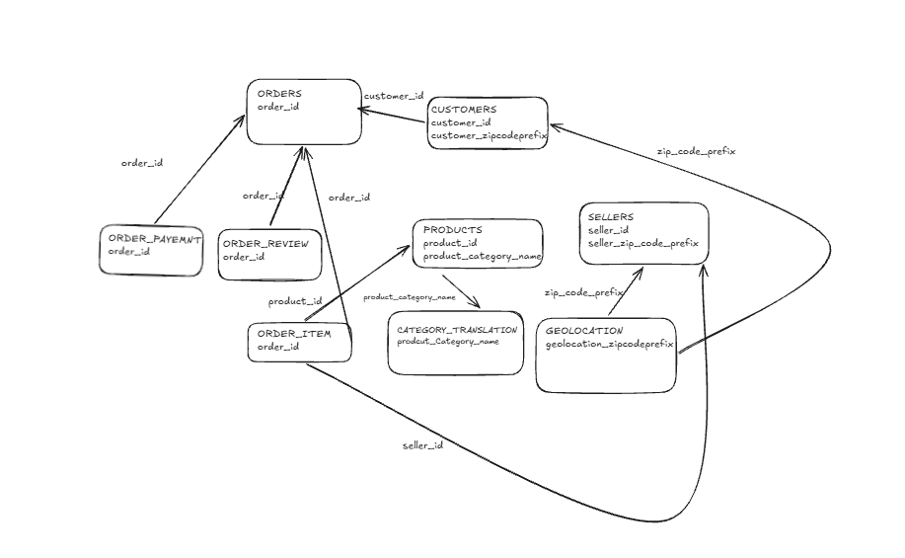

- The customers table has 99,441 rows and 5 columns. Each row is a customer tied to a single order, and it's worth noting that Olist actually creates a brand new customer_id every time someone places an order, so this table doesn't represent unique people. A person who ordered three times shows up here three times, each with a different ID.

- The orders table also has 99,441 rows and 8 columns. One row is one order, along with its status and the full delivery timeline, covering when it was purchased, approved, handed to the carrier, delivered, and when it was estimated to arrive.

- The order_items table is bigger, with 112,650 rows and 7 columns, because it's more granular than orders. One row here is one product line inside one order, so if someone bought three different products in a single order, that's three rows, all sharing the same order_id.

- The order_payments table has 103,886 rows and 5 columns. One row is one payment installment or method used on an order, so an order that was paid in installments, or split across two payment methods, ends up with multiple rows.

- The order_reviews table has 99,224 rows and 7 columns, with one row per review left on an order.

- The products table has 32,951 rows and 9 columns, one row per product, along with its category and physical attributes like weight and dimensions.

- The sellers table has 3,095 rows and 4 columns, one row per seller along with their location.

- The geolocation table is the odd one out, with over a million rows, 1,000,163 to be exact, but only 5 columns. Each row is a single latitude and longitude sample tied to a zip code prefix. A lot of rows share the same zip prefix, so this isn't a clean one-to-one table the way the others are.

- The category_translation table is tiny, just 71 rows, and it maps each Portuguese category name to its English version.

- To check the join keys, I used the isin method to compare each pair of tables and count how many rows on one side had no match on the other side. Order_items joined to orders on order_id with no orphans. Orders joined to customers on customer_id with no orphans. Order_items joined to products on product_id with no orphans. Order_items joined to sellers on seller_id with no orphans. Order_payments joined to orders on order_id with no orphans. Order_reviews joined to orders on order_id with no orphans. The only join that had a problem was products joining to category_translation on product_category_name, which had 623 orphans.

- Looking into those 623 orphans, most of them, 610 to be exact, simply had no category at all, meaning the value was missing rather than mismatched. The remaining 13 had real category names, portateis_cozinha_e_preparadores_de_alimentos with 10 products and pc_gamer with 3 products, that genuinely don't appear anywhere in the translation file. My guess is these categories were added to the product catalog after the translation table was last updated, so the reference file never caught up.

- One last note on geolocation. I didn't treat it as a strict foreign key join to anything else, because it doesn't behave like one. It only connects to customers and sellers through zip_code_prefix, and that's a loose many to many relationship, since one zip prefix can map to many different latitude and longitude points, and it isn't unique in geolocation either. In the schema diagram I drew this as a dashed line instead of a solid one, to show that it's a different kind of relationship than the rest.

